**Assignment Questions**

**Part A:**

**A.Q1:**  Execution plan:

Seq Scan on played_in (cost=0.00..1056.00 rows=14673 width=14)

Filter: ("position" = 1)

**A.Q2:**  Estimated cost:

Cost=1056

**A.Q3:** Execution plan:

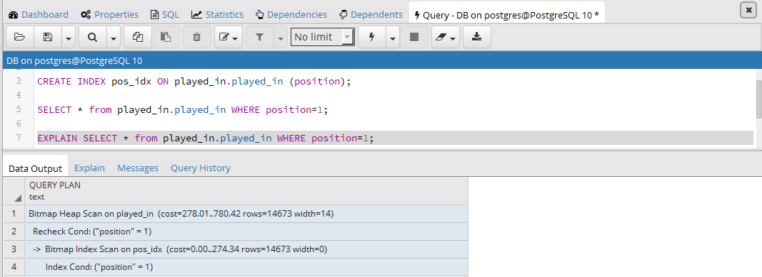

**A.Q4:** Estimated cost:

Cost=274

**A.Q5:**

**Part B:**

**B.Q1:** Execution plan:

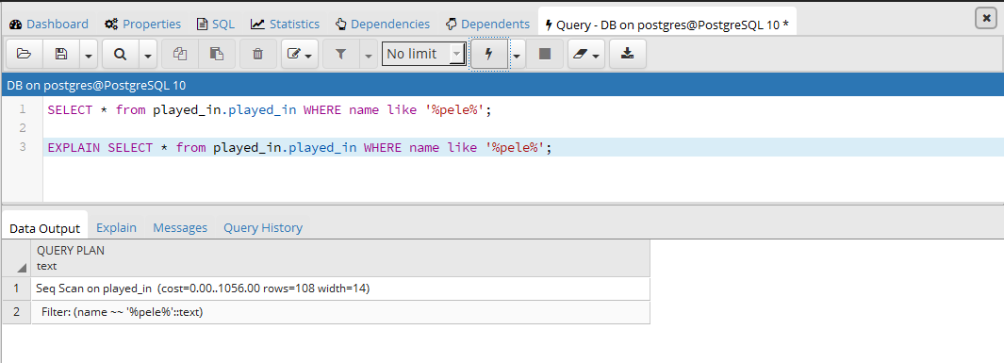

**B.Q2:** Estimated cost:

Cost=1056

**B.Q3:** Execution plan:

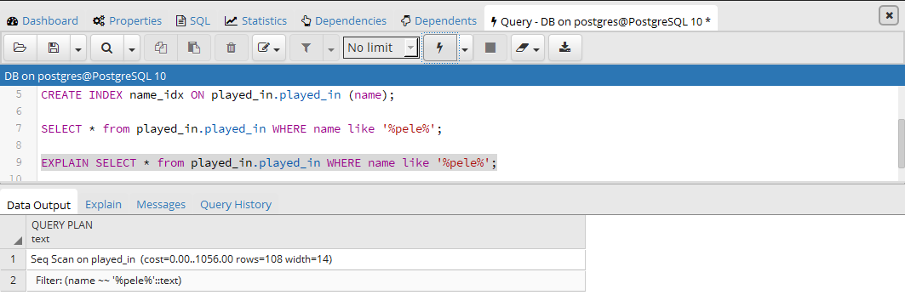

**B.Q4:** Estimated cost:

Cost=1056

**B.Q5:**

**Part C:**

**C.Q1:** Execution plan:

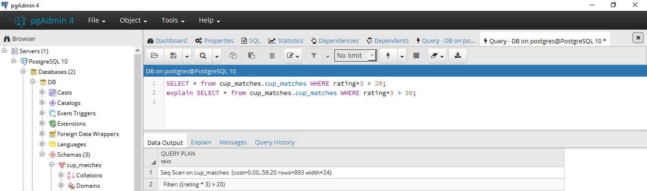

**C.Q2:** Estimated cost:

Cost = 59

**C.Q3:** Execution plan:

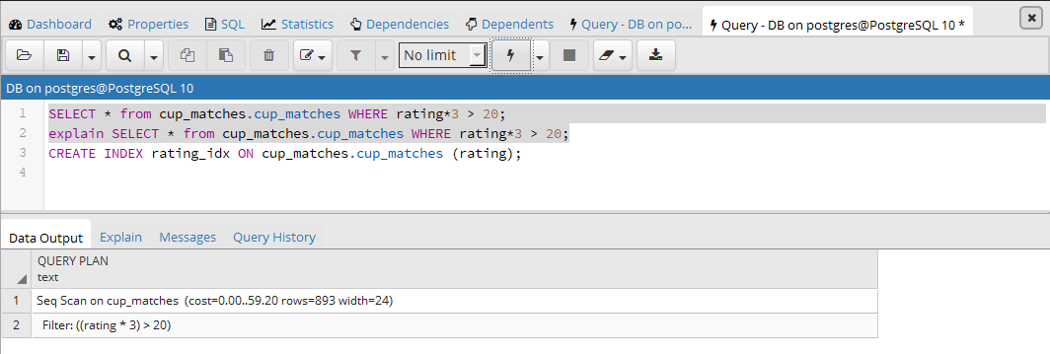

**C.Q4:** Estimated cost:

Cost = 59

**C.Q5:**

**Part D:**

**D.Q1:** Execution plan:

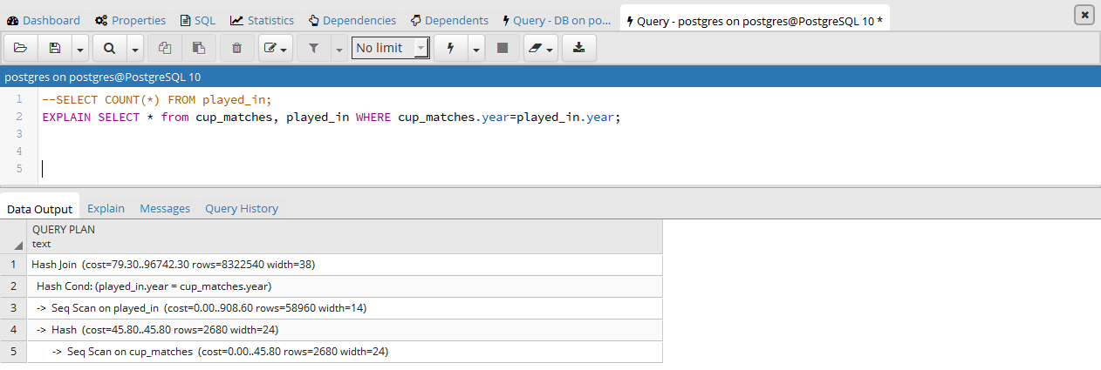

Cost: 96742

**D.Q2:** Execution plan: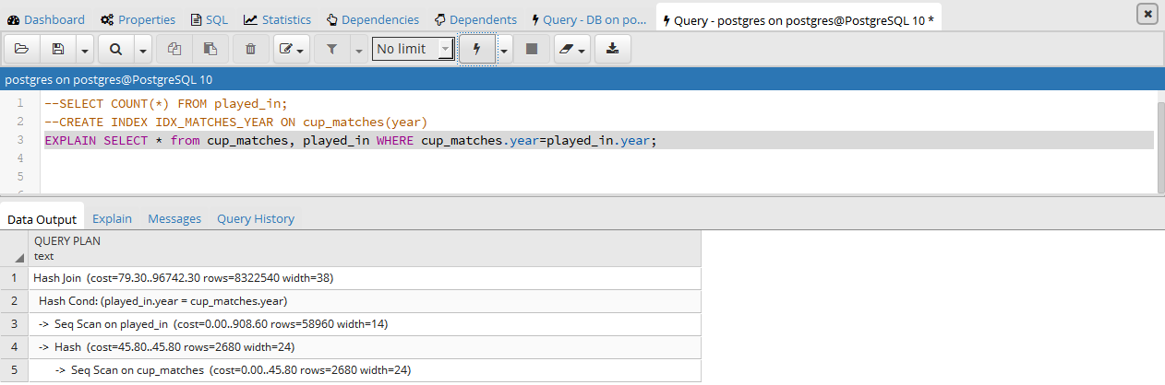

Cost= 96742

**D.Q3:**

**D.Q4:** Estimated cost: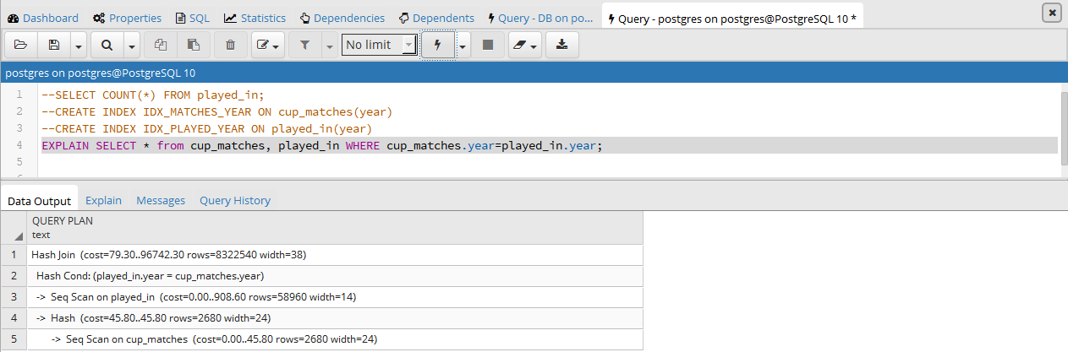

Cost = 96742

**D.Q5:**

**Part E:**

**E.Q1:** Execution plan: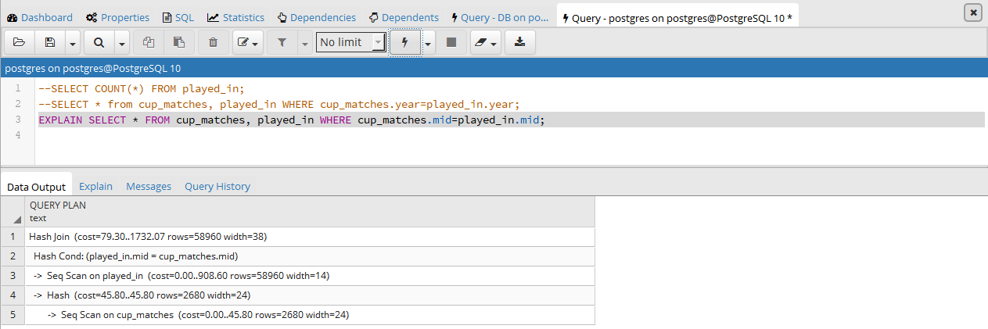

Estimated cost: 1732

Join algorithm used is hash join

**E.Q2:** Execution plan: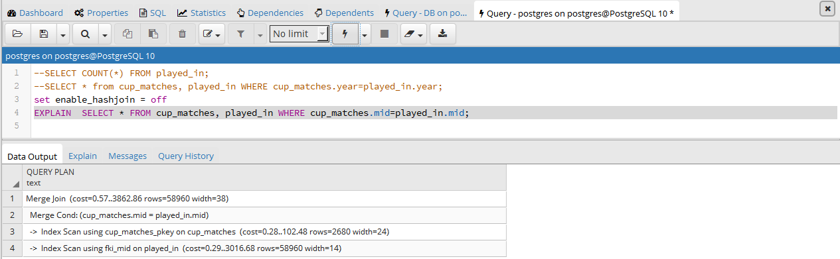

Estimated cost: 3863

Join algorithm used is merge join

**E.Q3:** Execution plan: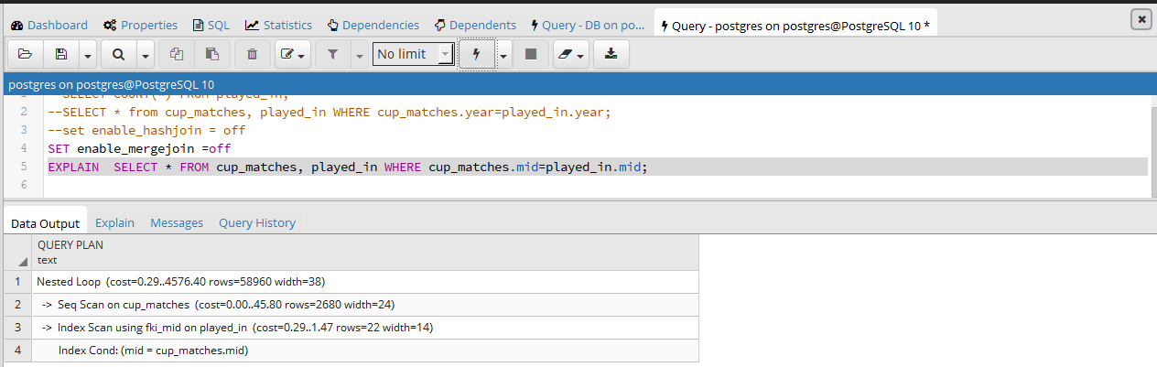

Estimated cost: 4576

Join algorithm used is nested loop

**PART F**

**Part A:**

**A.Q1:**  Execution plan:

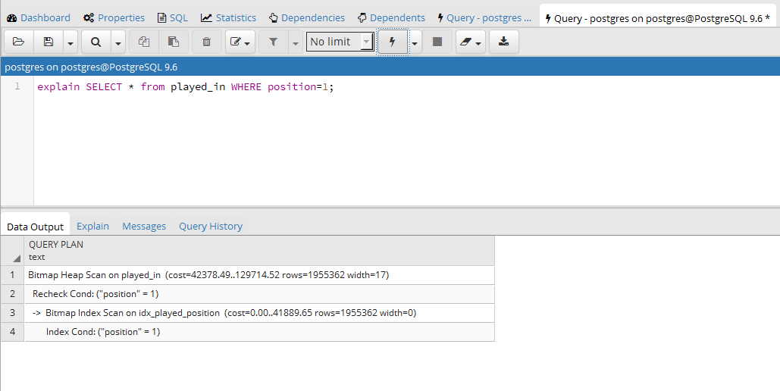

**A.Q2:**  Estimated cost:

Cost=129714

**A.Q3:** Execution plan:

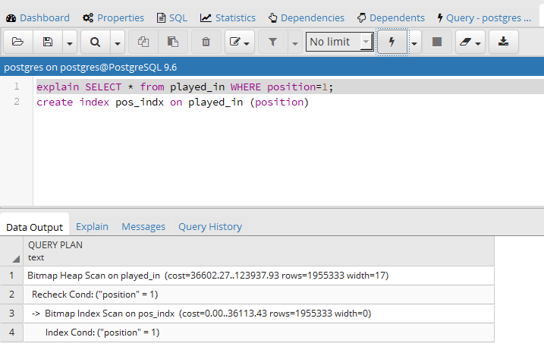

**A.Q4:** Estimated cost:

Cost=123937

**A.Q5:**

**Part B:**

**B.Q1:** Execution plan:

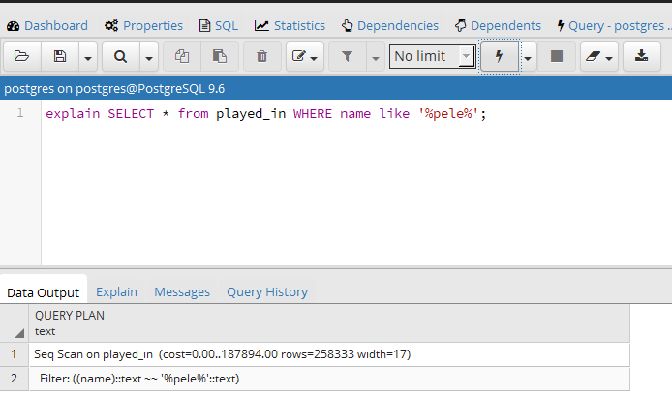

**B.Q2:** Estimated cost:

Cost=187894

**B.Q3:** Execution plan:

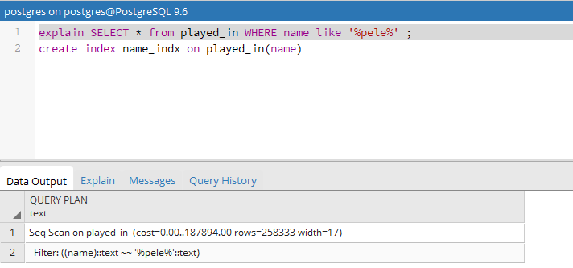

**B.Q4:** Estimated cost:

Cost=187894

**B.Q5:**

**Part C:**

**C.Q1:** Execution plan:

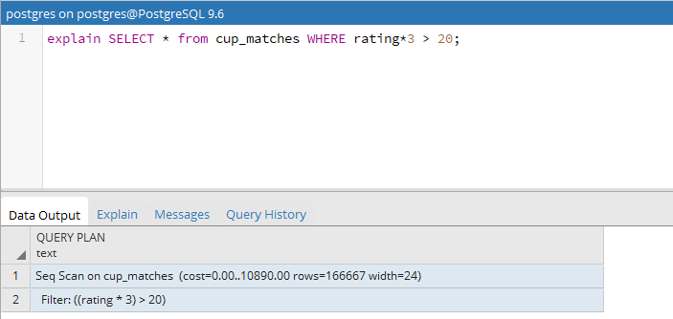

**C.Q2:** Estimated cost:

Cost = 10890

**C.Q3:** Execution plan:

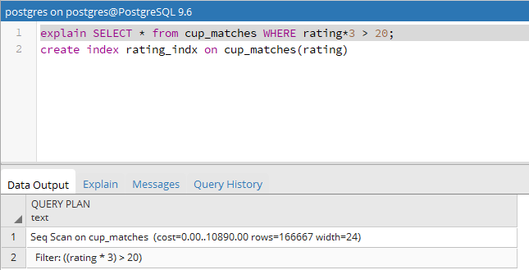

**C.Q4:** Estimated cost:

Cost = 10890

**C.Q5:**

**Part D:**

**D.Q1:** Execution plan:

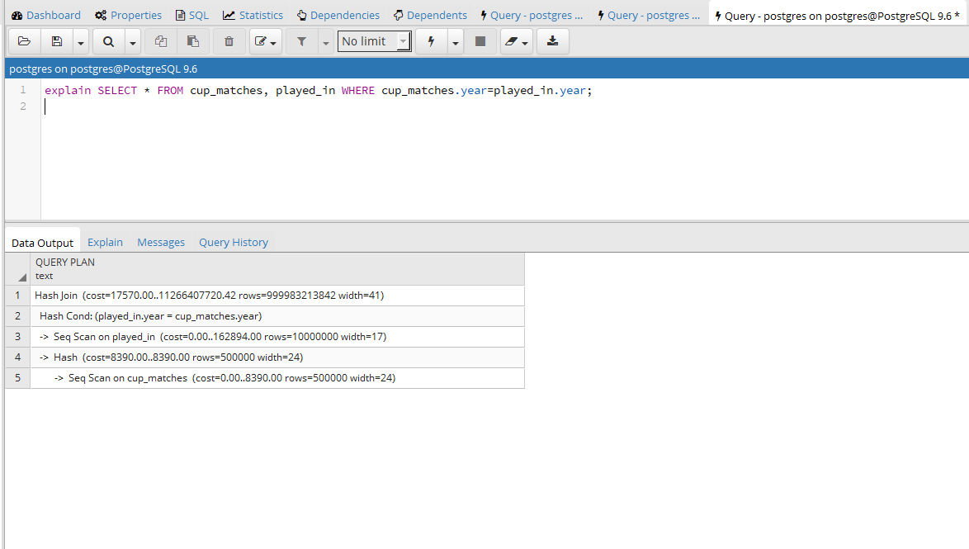

Cost: 11266407720

**D.Q2:** Execution plan:

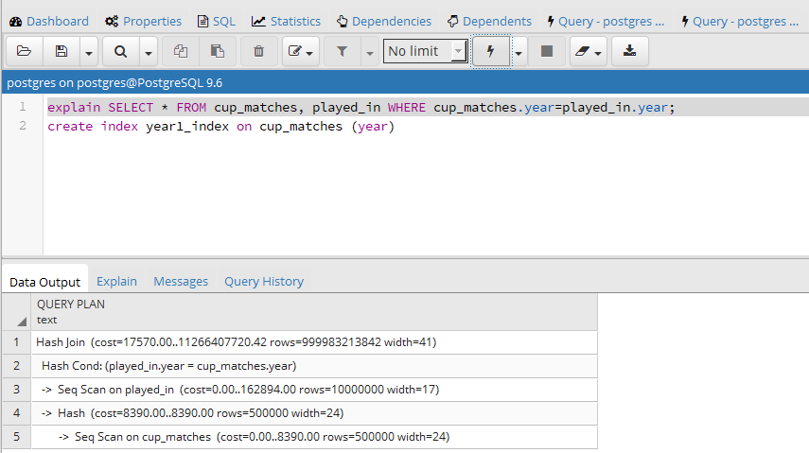

Cost: 11266407720

**D.Q3:**

**D.Q4:** Execution plan:

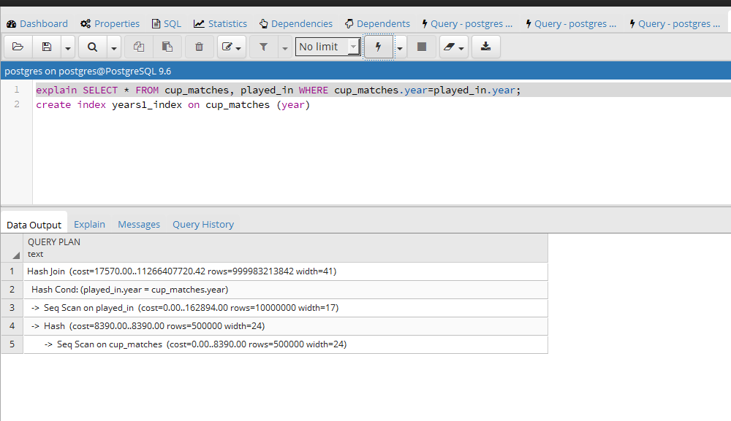

Cost = 11266407720

**D.Q5:**

**Part E:**

**E.Q1:** Execution plan:

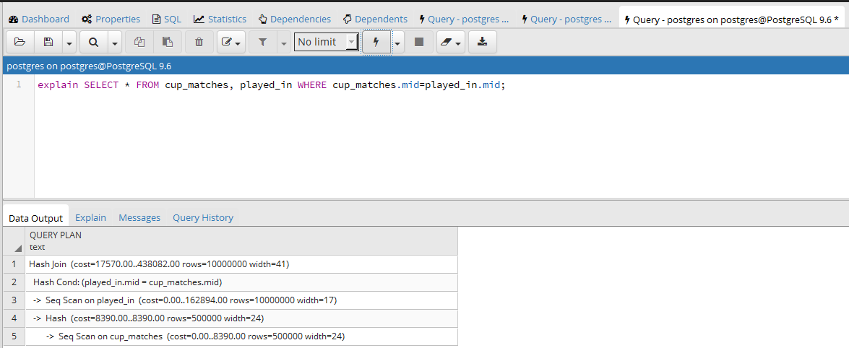

Cost: 438082

Join algorithm used is hash join

**E.Q2:** Execution plan:

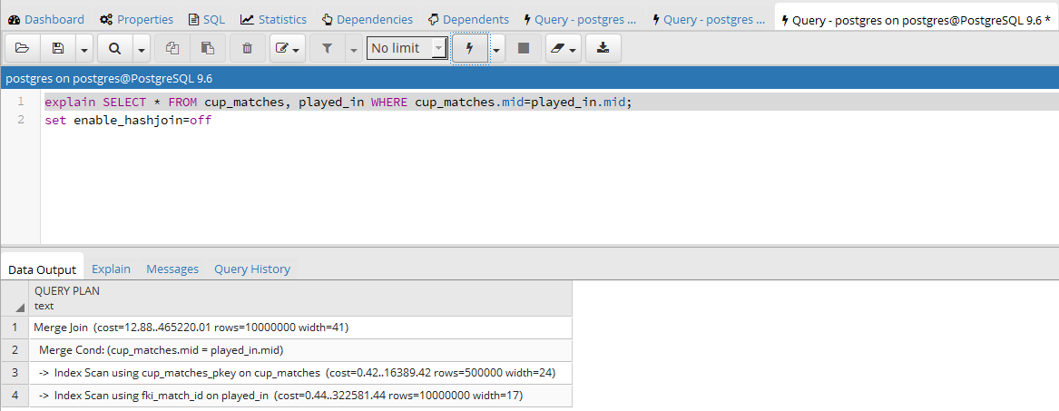

Cost: 438082

Join algorithm used is merge join

**E.Q3:** Execution plan:

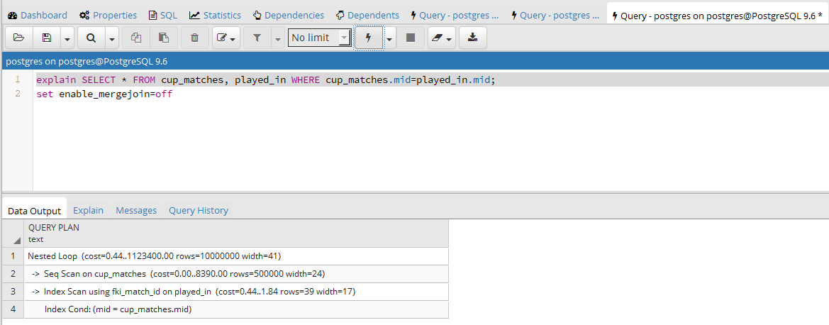

Cost: 1123400

Join algorithm used is nested loop join